Generate Document Template

# User Manual

Version 0.1

17/11/2023

# Table of Contents

1. Configuring Document Template in ACS (Alfresco Content Services) 3

1.1 Configuring Blank Document Template 3

1.2 Configuring Custom Document Template 4

2. Generate Document in DigiWorks 10

# 1. Configuring Document Template in ACS (Alfresco Content Services)

## Configuring Blank Document Template

**Generate Document Module for Node Templates Configuration:**

This Node Template Configuration aims to help IT Admin configure the blank template for the Generate Document Module. Go to **Repository > Data Dictionary > Node Templates** folder and upload empty document like Excel, Word, and PowerPoint.

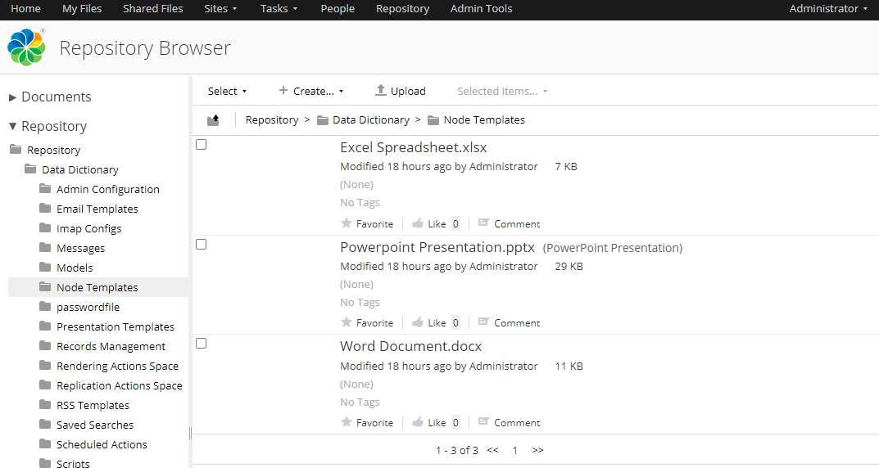

Go to DigiWorks and Log In, Click on **Documents** Tab > **Generate Document** Tab. The blank template is successfully added.

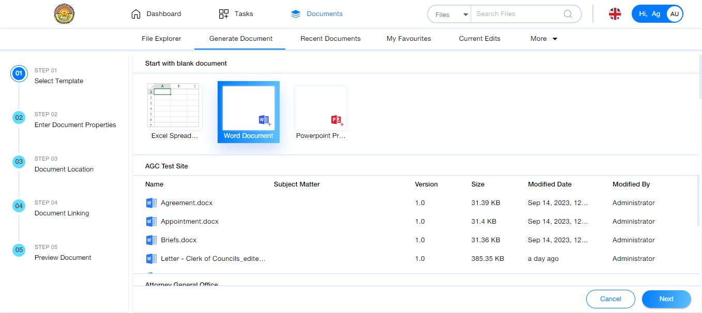

## Configuring Custom Document Template

**Generate Document Module for Templates Configuration:**

This Template Configuration aims to help IT Admin configure the custom template for the Generate Document Module. Please find below the steps to configure the custom template:

Go to ACS, select the Site (e.g. AG Office)

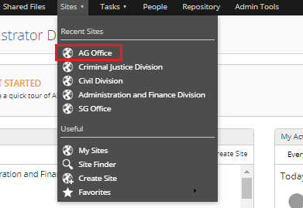

Go to Document Library and create the folder named "Templates".

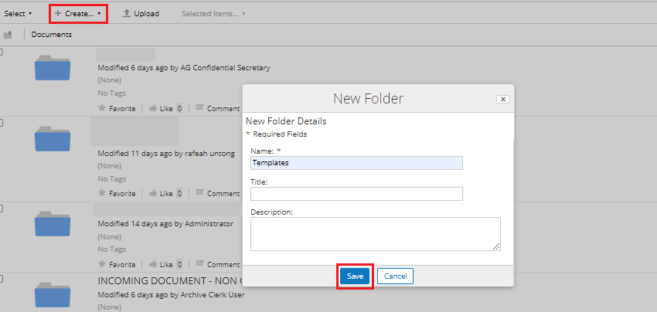

Click on the Templates folder and update *Change Type*, *Manage Aspects* and *Manage Rules* as mentioned in *Steps 4 to 7*.

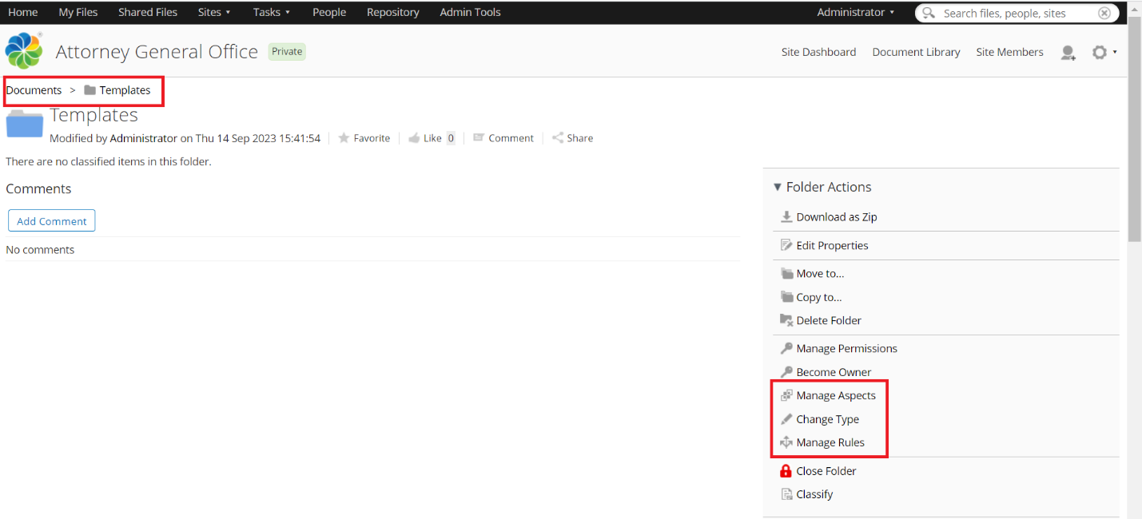

Click on "Change Type", select the "AGC Template Folder", and click "OK".

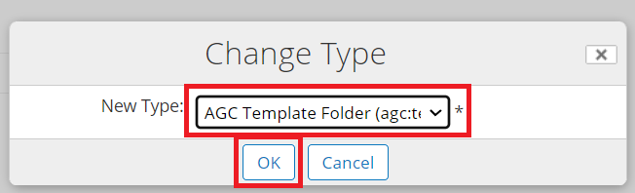

**Note:** *Once the folder type is successfully changed, it cannot longer be changed.*

Click on "Manage Aspects". Click on the + icon to add "AGC Template" and click on "Apply changes".

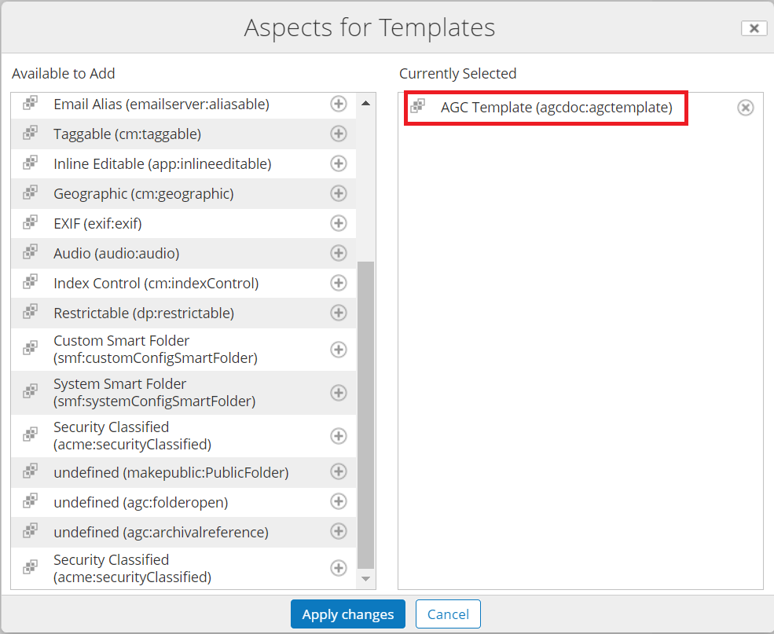

Click on "Manage Rule" and click on "Create Rules".

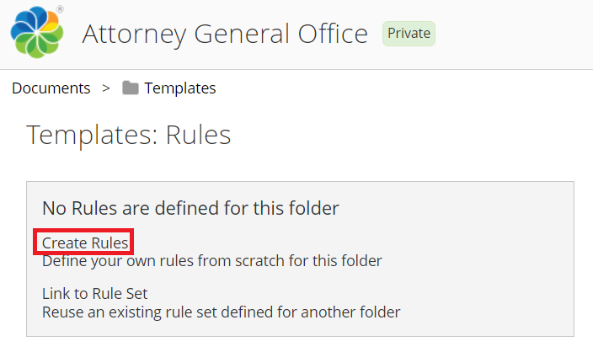

Fill in the fields as shown below and click "Create".

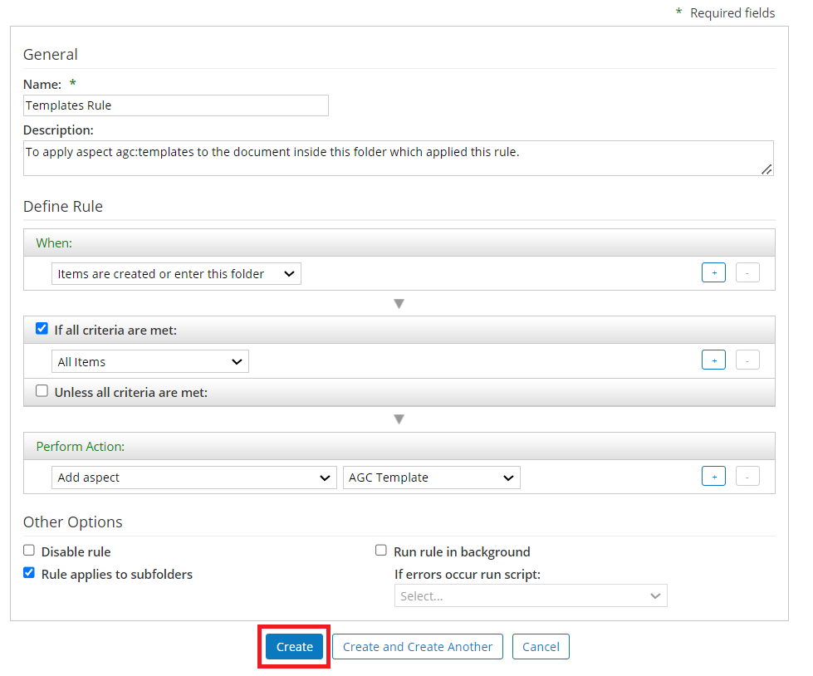

Rule created as shown below.

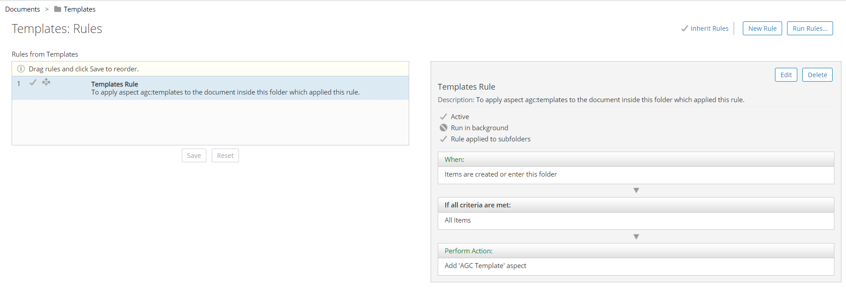

The same rule must apply for all Templates folders in other divisions, then apply the "Link Rule Set" as shown in Steps 12 to 14.

Go to Sites and select "My Sites". Select other divisions like Civil Division Site.

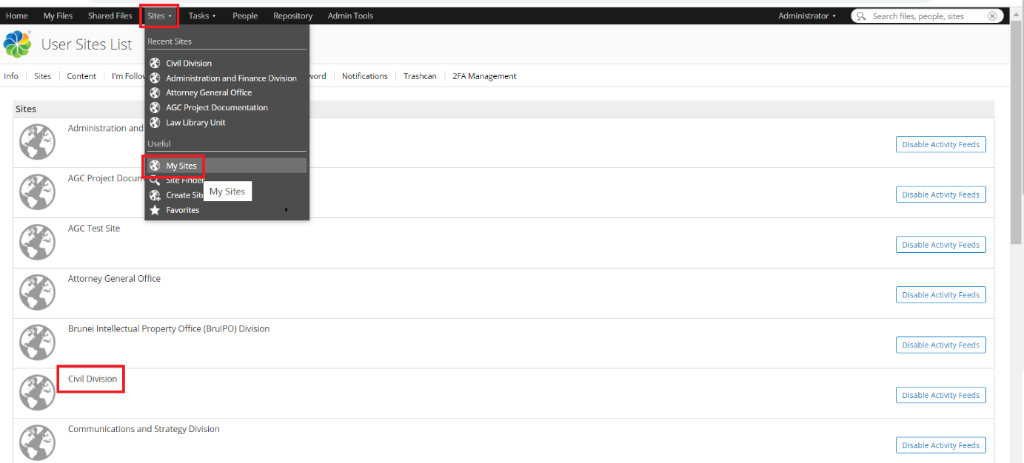

Go to Document Library and create the folder named "Templates."



Click on the Templates folder and click *Manage Rules*. Click on "Link to Rule Set".

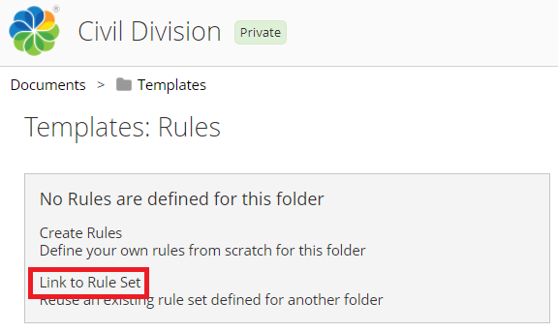

Select the Site which we configured earlier, "Attorney General Office". Select the "Templates" folder and click "Link".

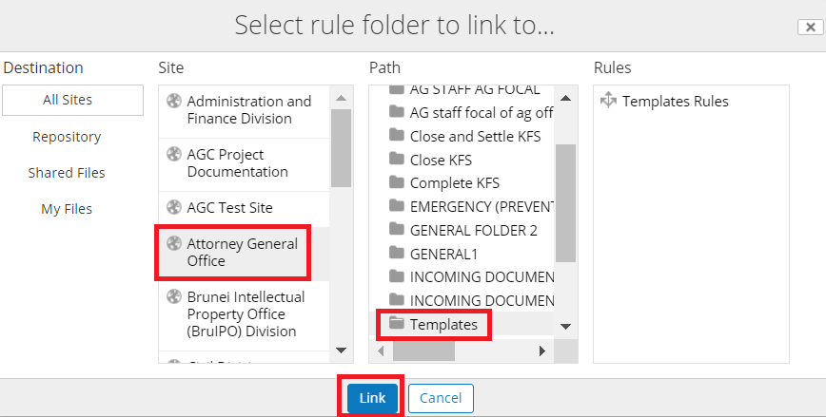

The rule will be Linked to the "Civil Division" Templates folder, as shown below. Click "Done".

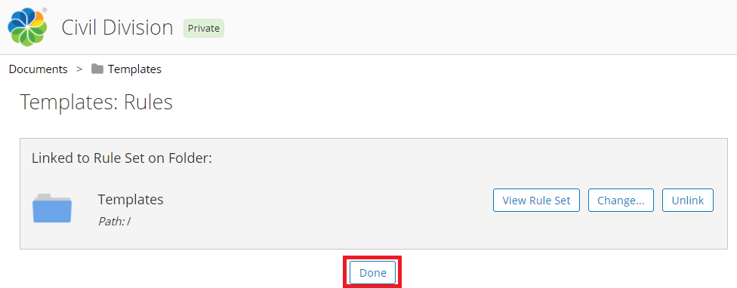

Prepare document template in Word Document, place the property name by referring to Content Model Document.xml.

Format for the property/metadata name: ${[propertyname]}

*i.e.* ${subjectmatter}, ${documentdate}, ${officername}, ${referencenumber}, ${documentreferencenumber}, etc please refer to the content model document.xml.

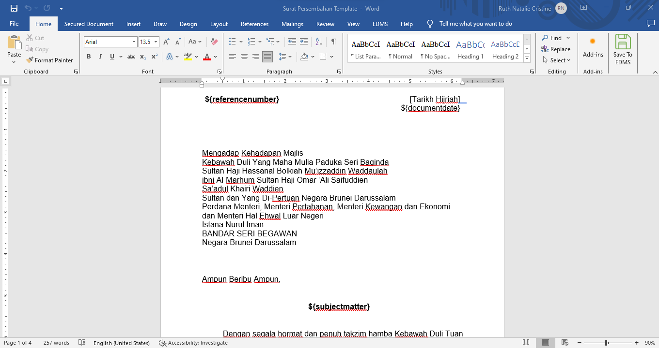

Upload the prepared document to the "Templates" folder.

Select the document.

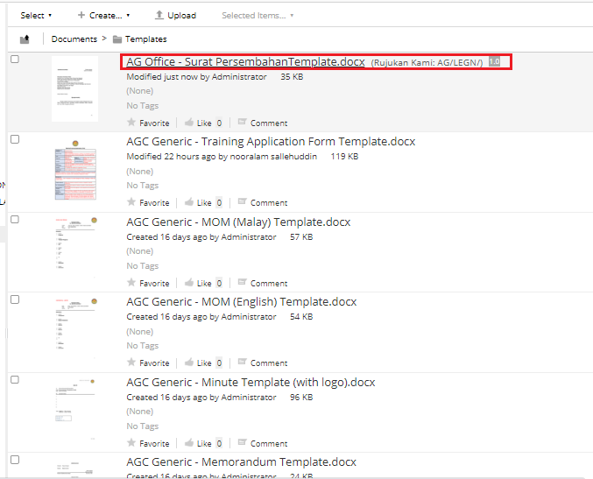

Click "Change Type", select the document type, and click "OK".

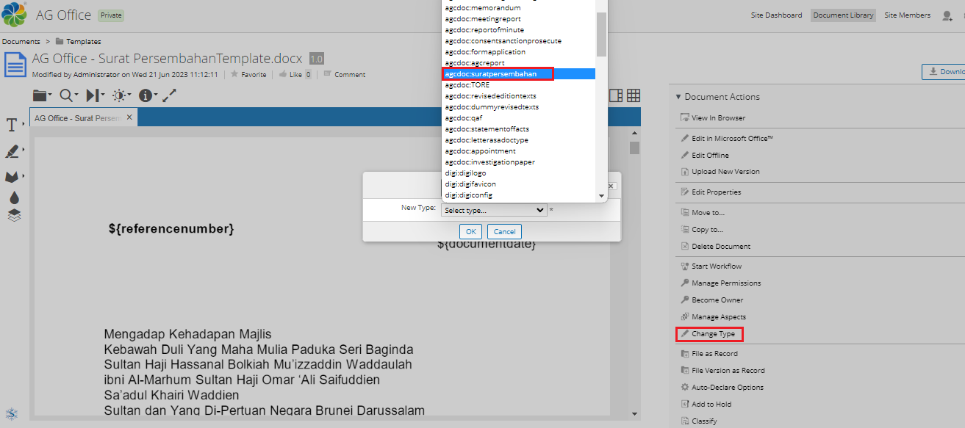

Once the document type is successfully changed, it cannot be changed anymore. If the IT Admin incorrectly selects the document type, it must be deleted and repeat *Steps 11 to 13*.

Note: Please make sure the template is added under "Manage Aspects" for the document. This "AGC Template" is automatically applied for all documents under the "Templates" folder based on the rule we applied for the "Templates" Folder.

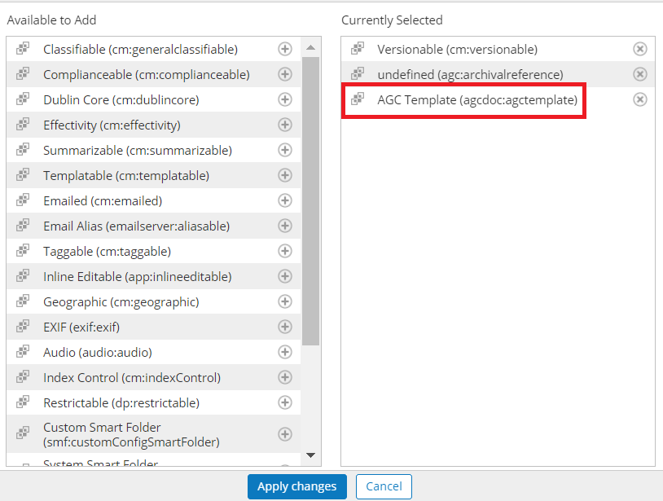

Go to DigiWorks and Log In, Click on **Documents** Tab > **Generate Document** Tab. The document is successfully added to the Generate Template under the Attorney General Office.

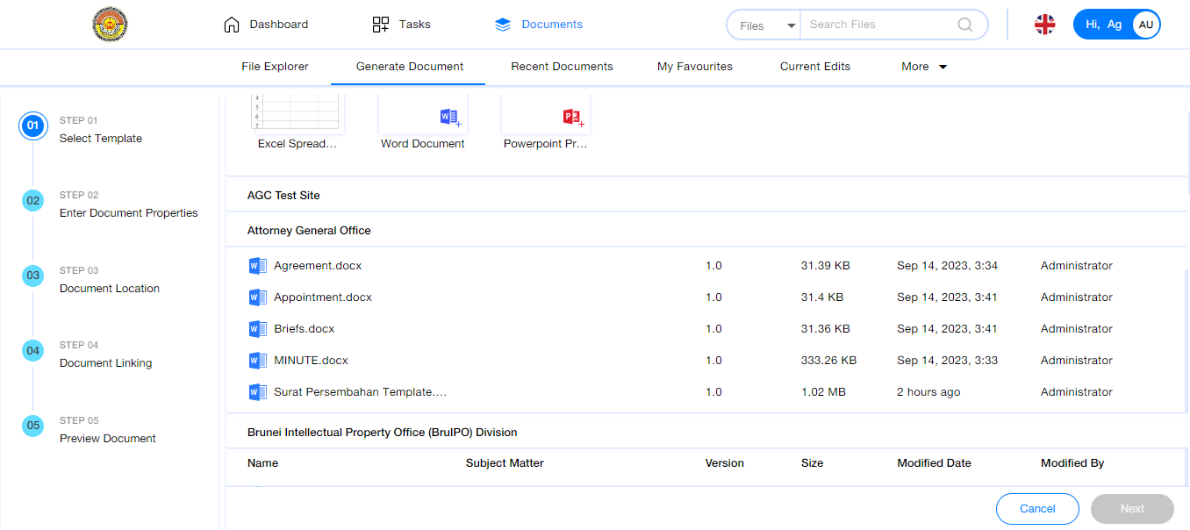

# 2. Generate Document in DigiWorks

1. Go to DigiWorks and Log In, Click on **Documents** Tab > **Generate Document** Tab. *Step 1*, select one of Template and Click **Next**.

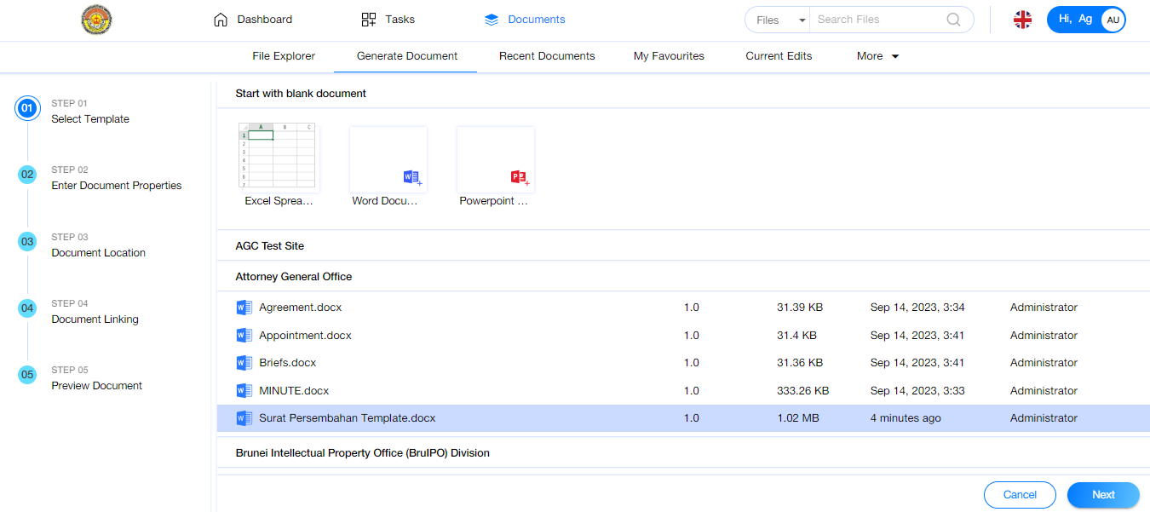

1. On *Step 2*, enter **all the metadata** and click **Next.**

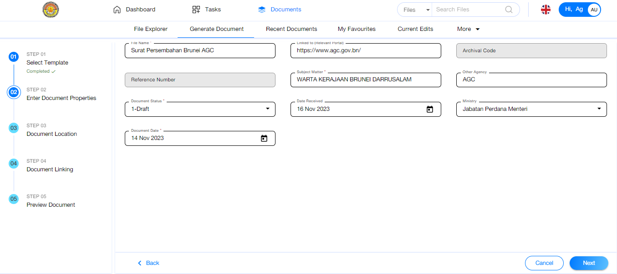

1. On *Step 3*, select the document location and click **Next.**

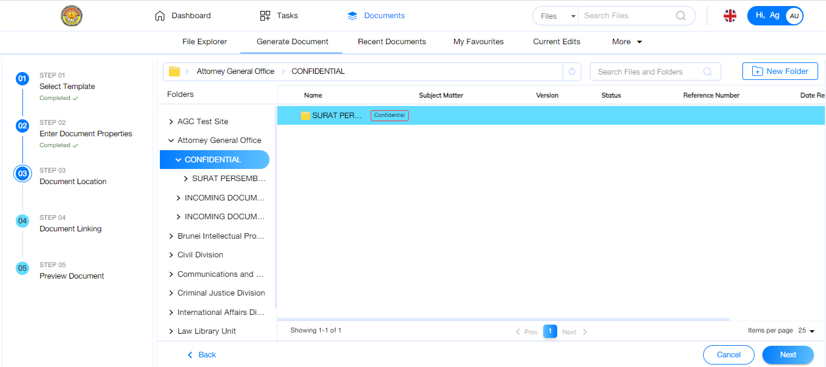

1. On *Step 4*, Click **Skip For Now** if do not want to link the document. If want to link the document, select the folder/document and **Link Type** to link it and click **Next.**

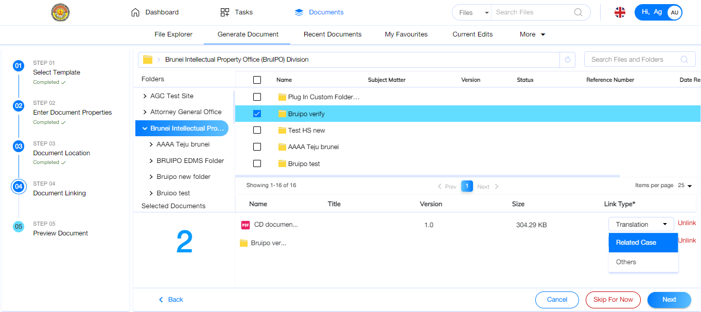

1. On *Step 5*, Click **Save** to save the document to the selected location on *Step 3*.

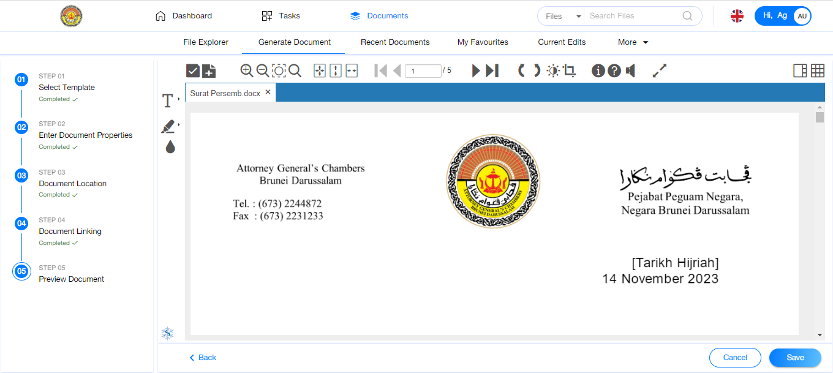

1. The document is successfully saved to the selected location.

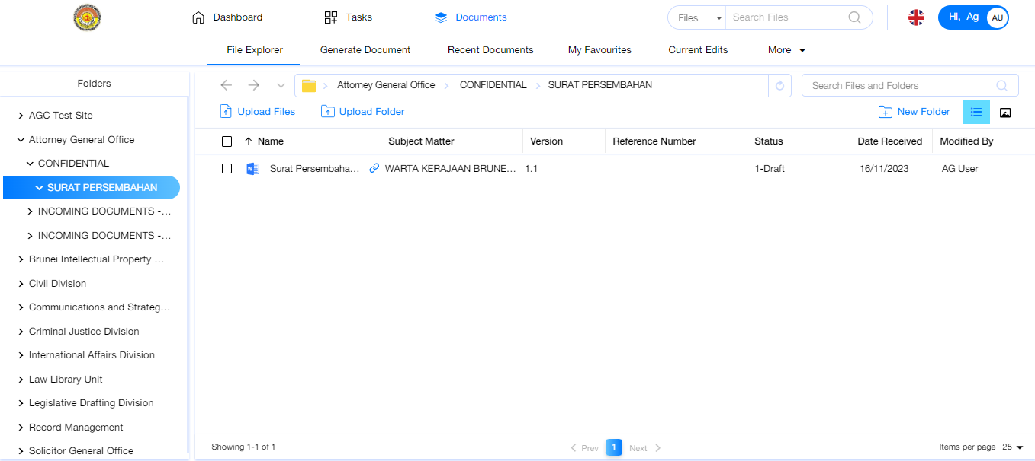

1. Preview the document to check the metadata generated inside the document.

